Substance Use and Canadian Post-Secondary Schools Amid COVID-19
By: Marcel Gemme

The issues surrounding drug and alcohol use among Canadian college and university students are recognized among academia, healthcare professionals, and public officials. The COVID 19 pandemic has certainly cast a light on the connection between isolation, stress, fear, and substance use. During the second wave of the pandemic, national surveys found Canadian mental health was eroding as the pandemic continued.

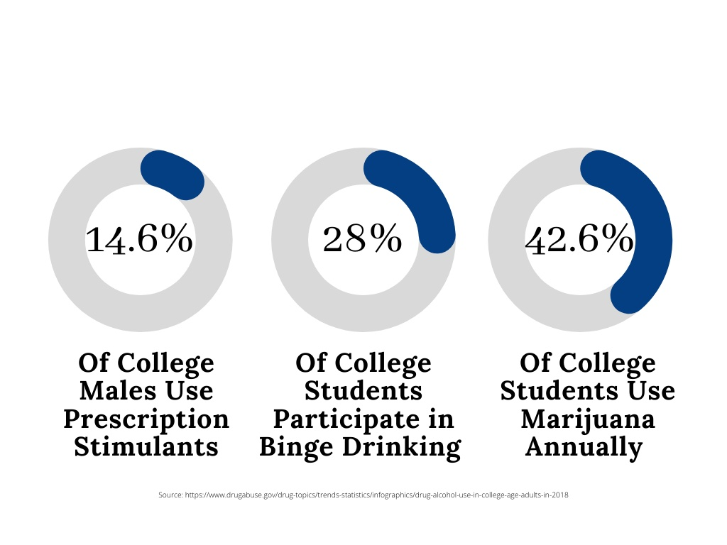
In 2018, the National Institute on Drug Abuse saw a seven percent five-year increase in marijuana use among college students. Approximately one in seventeen college students reported daily or near-daily use of marijuana. However, there was a significant five-year drop in prescription drug misuse from 2013 to 2018. Prescription stimulants continued to remain the most popular prescription drug of choice among college men, with 14.6% using the drug. In 2018, binge alcohol use fell below 30%, with roughly 28% of college students consuming five or more drinks in a row.

Campus life has always been the primary predisposing factor leading to substance use. College life is often characterized by increased academic pressure as well as freedom. However, the COVID 19 pandemic and government intervention have removed numerous freedoms. Canadian colleges and universities have battled with COVID 19 closures, students moving to online learning, final exams being moved, canceled, done online, or even replaced with additional coursework.

Ongoing restrictions and social distancing have all but terminated convocation ceremonies, student gatherings, and most social lives. On top of all this, thousands of post-secondary students across Canada are petitioning to close university and college campuses and move classes and exams entirely online. Most universities across the country suspended all in-person learning and moved as much as possible to online learning. However, some universities have explored opportunities to celebrate graduates in alternative ways.

Campus life has all but been diminished, yet many of the stressors that college and university students face have been amplified by ongoing media fear, restrictions, and uncertainty with COVID 19. Most college students indulge in drugs due to various reasons, such as peer pressure and the need to overcome college stressors. Students are also influenced by their friends to participate in drug use in the name of relaxation. Now, it is the stressors of COVID 19 and pressure to participate in drug or alcohol use to escape the pandemic.

Research has shown throughout the entirety of this pandemic, that people affected by COVID 19 may have a high burden of mental health problems. Some of these problems include depression, anxiety disorders, stress, panic attacks, irrational anger, impulsivity, sleep disorders, emotional disturbance, and suicidal behavior. According to the Centre for Addiction and Mental Health (CAMH), substance use is also on the rise in Canada during COVID 19. A recent poll found that 25% of Canadians aged 35 to 54 and 21% of those aged 18 to 34 have increased their alcohol consumption since restrictive measures were put in place.

Substance use impacts college students in a significant way. Most of the drugs used by students affect cognitive functions, such as memory, concentration, and attention. Impaired cognitive functions ultimately deteriorate academic performance. Coupled with the stress of the pandemic, colleges and universities changed class schedules, exams, in-person learning, and canceled events—many college students have new reasons to misuse drugs and alcohol. In a study examining the effects of COVID 19 on college students, 71% of those surveyed indicated increased stress and anxiety.

Multiple stressors were identified that contributed to the stress, anxiety, and depressive thoughts. This included fear and worry about their health and their loved ones, difficulty concentrating, disrupted sleeping patterns, decreased social interactions due to physical distancing, and increased concerns about academic performance. In an effort to cope with the stress and anxiety, students chose either negative or positive coping mechanisms.

The most difficult parts for many college and university students are believing these changes will not be permanent, attending class or online learning daily, and keeping their momentum and motivation going. Because these changes occurred, it does not mean that students have stopped their flow but rather, adjusted the rhythm to keep moving. Substance use is a recognizable problem among college and university students; unfortunately, addiction issues became amplified amid the pandemic.

As schools scramble to figure out how to provide mental healthcare for students during the pandemic, the responsibility remains with students to ask for help when they need it and reach out to others who could be struggling. Students should continue to focus on structure and routine, personal health, and happiness. Finally, maintain hope and know this is not permanent as generations before have been through crisis and came out stronger.

If you are struggling with substance use or are having difficulty managing stress, access local resources. College campuses provide student health services, while some offer collegiate recovery communities. Most colleges advertise 12-step support groups, peer support, and other services for substance use. Take advantage of local resources, and if that is not enough, reach out to the community and access provincial or private resources.

Additionally, if you notice a friend struggling, intervene immediately, do not wait hoping that things will get better. Speak to your local counselor, find out how you can help, and be there to support the individual who needs the assistance. Everyone has struggled in some way during this pandemic, however resources are available in Alberta and people are willing to help, regardless of the situation. It is typically easier to help another person but harder to help yourself. Please do not ignore the indicators, whether it involves yourself or a friend.

-About the author-
Marcel Gemme is Drug and Alcohol Treatment Specialist, DATS, that has been helping people struggling with substance use for over 20 years. He first started as an intake counselor for a drug rehabilitation center in 2000. With drug and alcohol problems constantly on the rise he utilized his website, Drugrehab.ca and community outreach to spread awareness. His primary focus is threefold: education, prevention, and rehabilitation.


Sources

- https://www.drugabuse.gov/drug-topics/trends-statistics/infographics/drug-alcohol-use-in-college-age-adults-in-2018

- https://www.change.org/p/close-all-schools-in-canada-immediately-to-stop-covid-19?pt=AVBldGl0aW9uAMZcMwEAAAAAXmvM7O0xdcdiNmYwYmY2NQ%3D%3D&source_location=topic_page

- https://pubmed.ncbi.nlm.nih.gov/33093946/

- https://www.camh.ca/-/media/files/pdfs---public-policy-submissions/covid-and-mh-policy-paper-pdf.pdf

- https://pubmed.ncbi.nlm.nih.gov/32805704/

