Fire Evacuation synopsis for Faculty
Knowing your responsibilities ahead of time means that you will have a better response than you would otherwise. This is a brief synopsis of the Fire Evacuation procedures as they pertain to Faculty and Instructors. This synopsis is brief and may get you by if you cannot attend the educational sessions in September. Your own safety is paramount.

Fire Evacuation
Many of you are familiar with the Concordia Fire Evacuation procedures although it may have been some time since you have attended a session. It helps with any emergency information or practices to have them in the short term memory, to keep it easy to recall.

Instructors are responsible for:
- Knowing the Evacuation Routes and Muster Points that are posted in each classroom in which they teach.
- Instructing students in evacuation procedures both at the beginning of the term and when the alarm sounds. Instructions include:
  - Do not pick up your books or bags.
  - Walk single file out of the classroom, do not run.
  - Do not use elevators.
- Pre-planning for Evacuation of Persons Requiring Assistance (See Page 3.);
- When the alarm sounds, leading the evacuation of all students from classrooms via established fire exit routes (see Evacuation Routes and Muster Points posted in each classroom);
- Instructors who are members of a Response Team (a) evacuate their class to the designated muster point for that classroom and (b) report to the Radio Response Personnel at the muster point.
- Following the directions of Response Team Members at all times;
- After 4:00 pm and on the weekends, leading students to Muster Point 1 (Page 2) and report there to the Response Team Member security or custodial.
- Communication, the accurate and immediate reporting of information, between all members of the Emergency Response Team is crucial to directing the appropriate emergency agency to areas of the campus where people may be at risk.

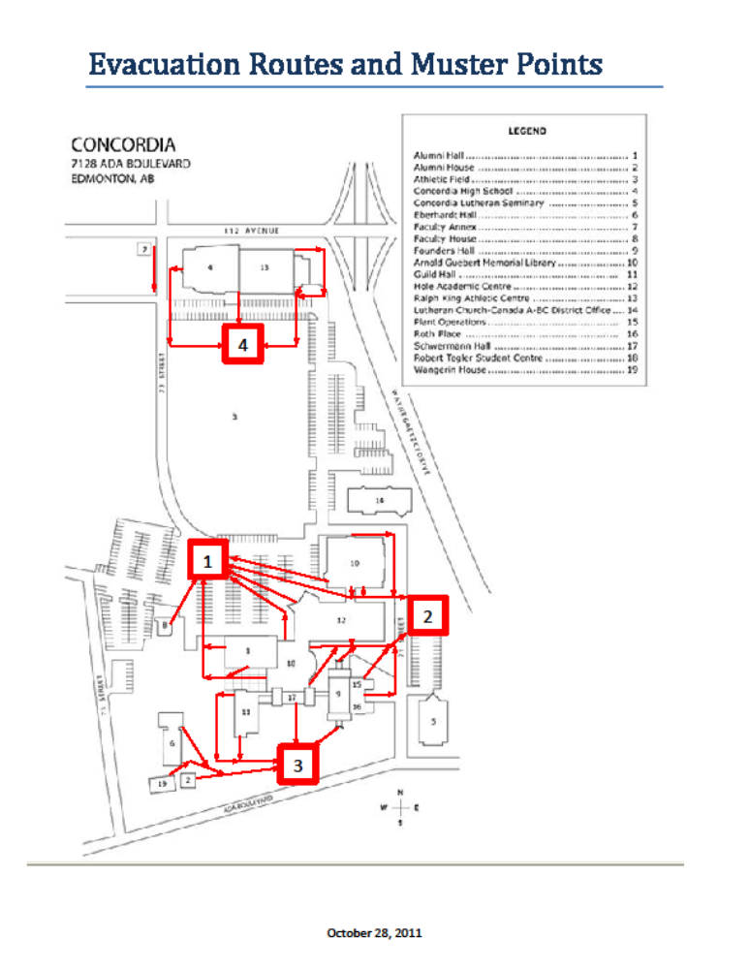

Evacuation of people requiring assistance
Instructors who have people in their classes unable to walk up stairways or who use wheelchairs, prepare in advance to deal with an emergency evacuation. Elevators are not to be operated during an emergency evacuation.

1. The instructor ahead of time:
a. Plans to remain with the student who requires assistance to evacuate.
b. Appoints a student/s to lead the evacuation of the class in the case of an emergency or alarm.
c. Together with the appointed student, reviews the Emergency Evacuation Route and Muster Point maps posted in the classroom.
d. Assists with the evacuation of the student with the disability.
2. In the event of an emergency evacuation:
e. The instructor asks the appointed student/s to lead the class along the emergency Evacuation Route to the Muster Point.
f. The instructor assists the disabled student from the classroom and closes the door.
g. The instructor moves the student through at least one fire separation and remains by the evacuation stairwell with the student until all other students have evacuated the area and a Response Team Member comes to help. Close the door behind you.
h. The Response Team Member asks the student how s/he should be evacuated, especially if s/he is confined to a wheelchair.
i. When possible, the instructor assists the Response Team Member with the evacuation of the disabled student.
  - If a Response Team member does not appear, the instructor leaves the student and reports the location of the student with the disability to the Radio Response Personnel at the muster point.
  - Trained emergency rescue personnel evacuate the student with a disability.

Fire Separations

Fire separations are building components (walls, doors, ducts, etc) that retard the spread of fire for a period of time. At Concordia often these are stairwell doors or walls between buildings. See the next page for an examples of Fire Separations. Ensure all doors leading into the separation are closed and latched.


